AMAZON S3

How to create S3 bucket at AWS?

**Create a New Bucket**

In the S3 dashboard, click the **Create bucket** button.

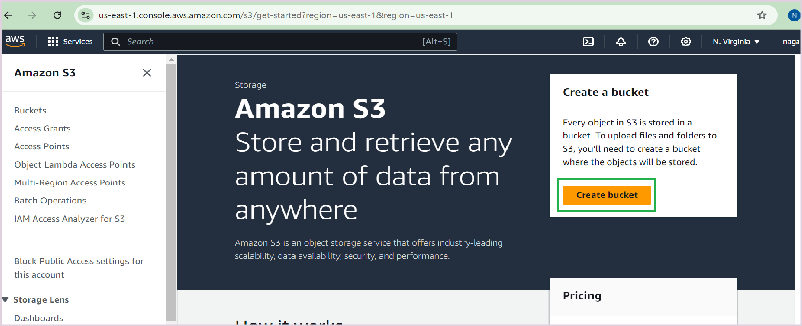

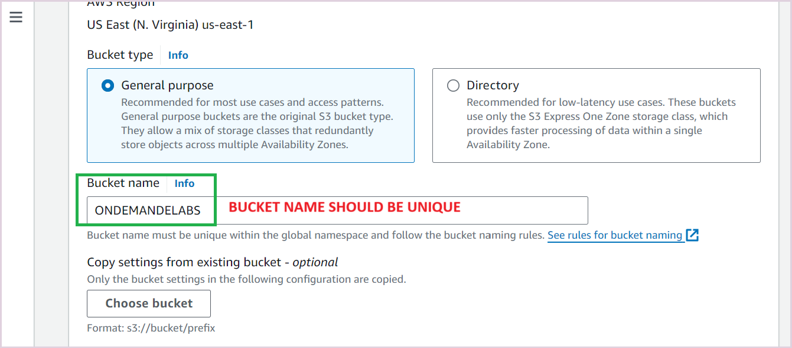

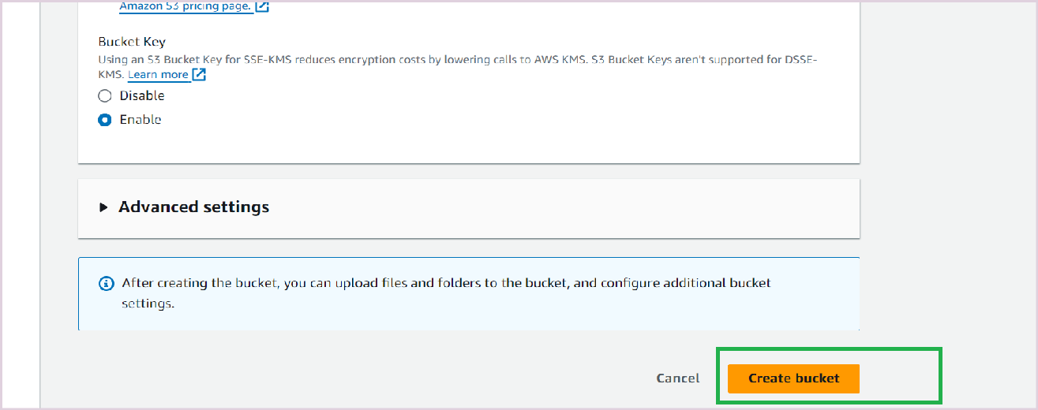

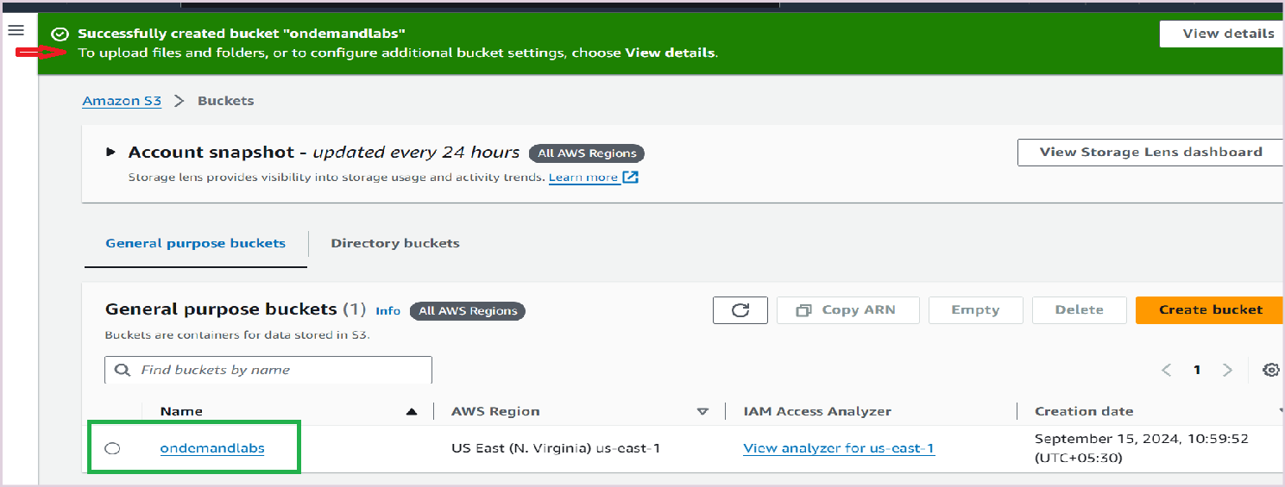

HOW TO UPLOAD OBJECTS?

To open ondemandlabs bucket, and click on **upload** button

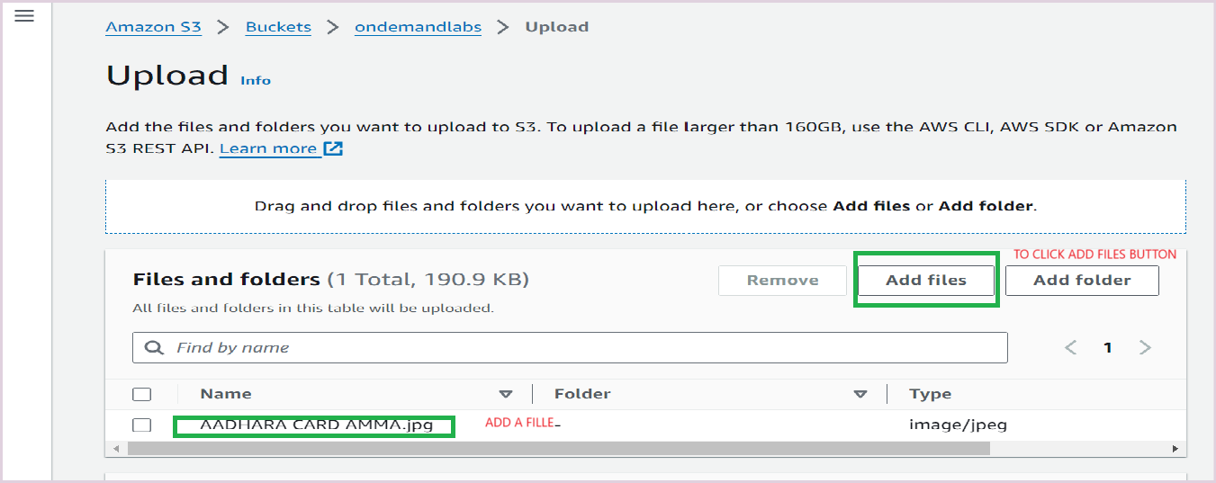

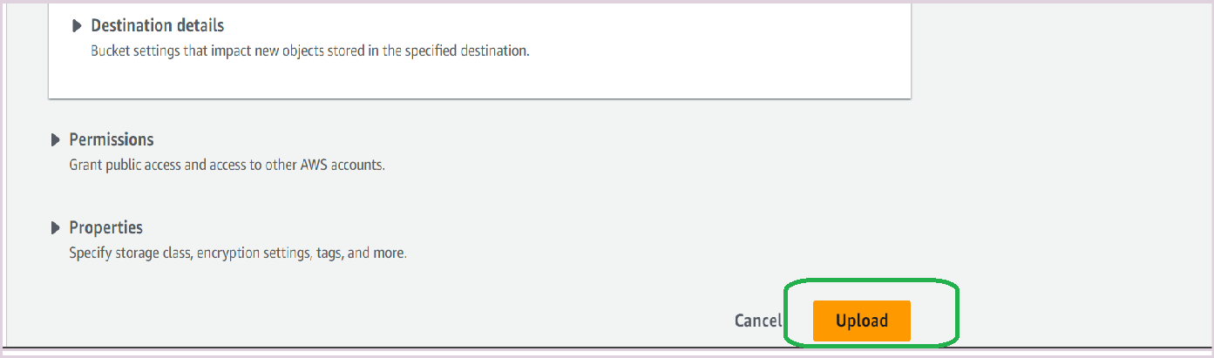

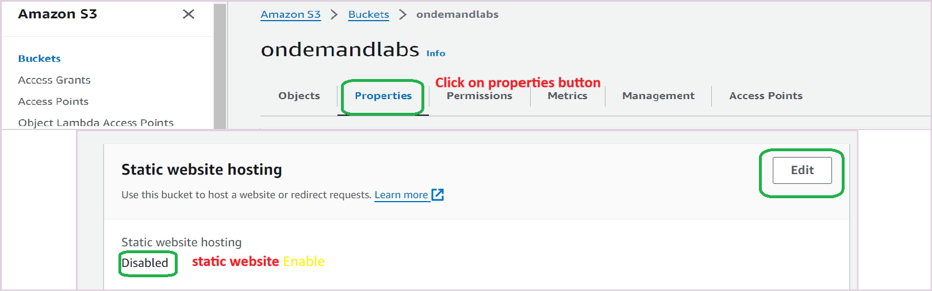

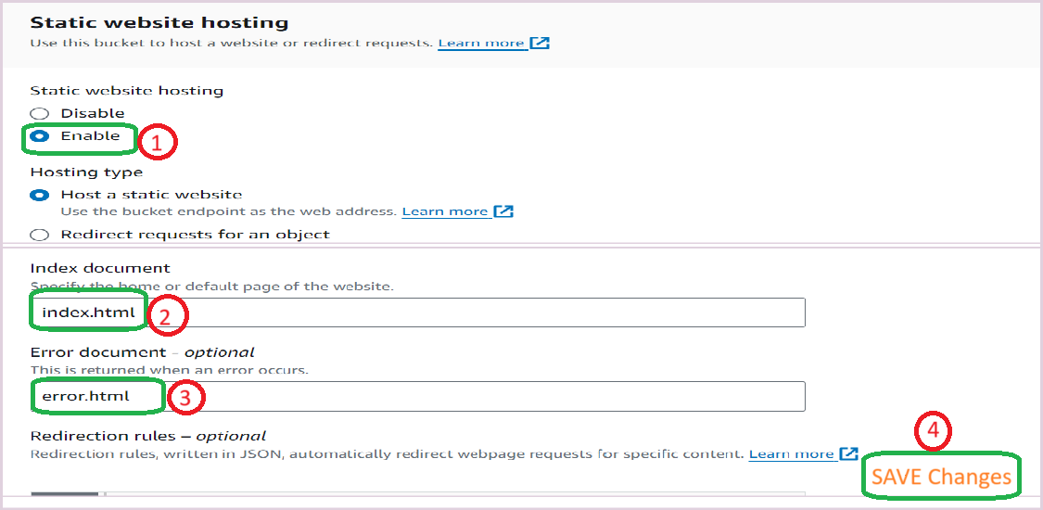

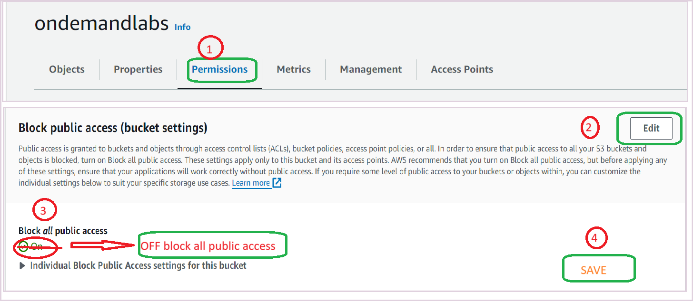

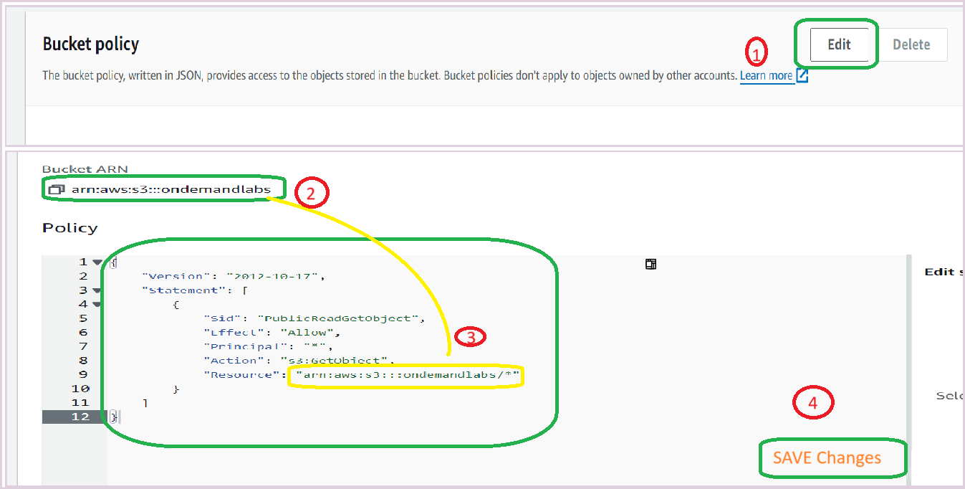

Bucket Policy Code

{

"Version": "2012-10-17",

"Statement": [

{

"Sid": "PublicReadGetObject",

"Effect": "Allow",

"Principal": "*",

"Action": "s3:GetObject",

"Resource": "arn:aws:s3:::asdfghjkghj/*"

}

]

}

